

TEXT DELETED AS PERSONAL ONLY TO CLIENTS



**WELCOME**

Welcome to our second newsletter.

This newsletter is a personal link from us to all our clients – not least as a reminder that we are here at the end of a phone, email, text, Skype….

We use our newsletter to give tax tips which could reduce your tax bill and allow you to keep one step ahead of the taxman.

We hope that you will find something of interest whether you are employed or self employed, run your own company or let a property.

If you need further advice on any of the areas covered, then please call or email as below.

**REMINDER:**

**CONTACT DETAILS**

**Woking Office: 01483 473494**

**Dorchester Office:**

**01300 341094**

**Mobile: 07831 502165**

**Email: mail@naldrettaccountants.co.uk**

**Website:**

**www.naldrettaccountants.co.uk**



**MAY 2014**

**Mon 31st May**

* **Bank holiday**
* **P60’s to be given to all employees**

**JUNE 2014**

**Thurs 19th May**

* **CIS submission for May**

No other deadlines for these months but there are important ones in July not least **2nd payment on account**.

**TAX TIPS YOU MIGHT NOT KNOW….**

**HAVE YOU MADE A WILL?**

Many assume that when they die their spouse will inherit everything. That is not the case should you die intestate.

Under intestacy rules the surviving spouse receives personal chattels plus £250,000 value plus 50% of what is left – the remainder goes to any children.

We can help if you have not made a will or want it updated.

**IN THIS ISSUE**

* Jennifer’s’ Blog
* May/June Dates to Remember
* Tax Tips you might not know
* Business Tax Tips and Dodges
* You have been warned!
* Company Tax Tips and Dodges

**COMPANY MOBILE PHONES**

Mobile phones provided by a company to its directors and/or employees are exempt from tax and NIC - limited to one handset per person. The contract must be between the business and the phone operator.

The exemption covers the phone, line rental and cost of private calls paid for by the employer on that phone.

**JENNIFER’S BLOG**

Meanwhile the cartoon below might make you smile….

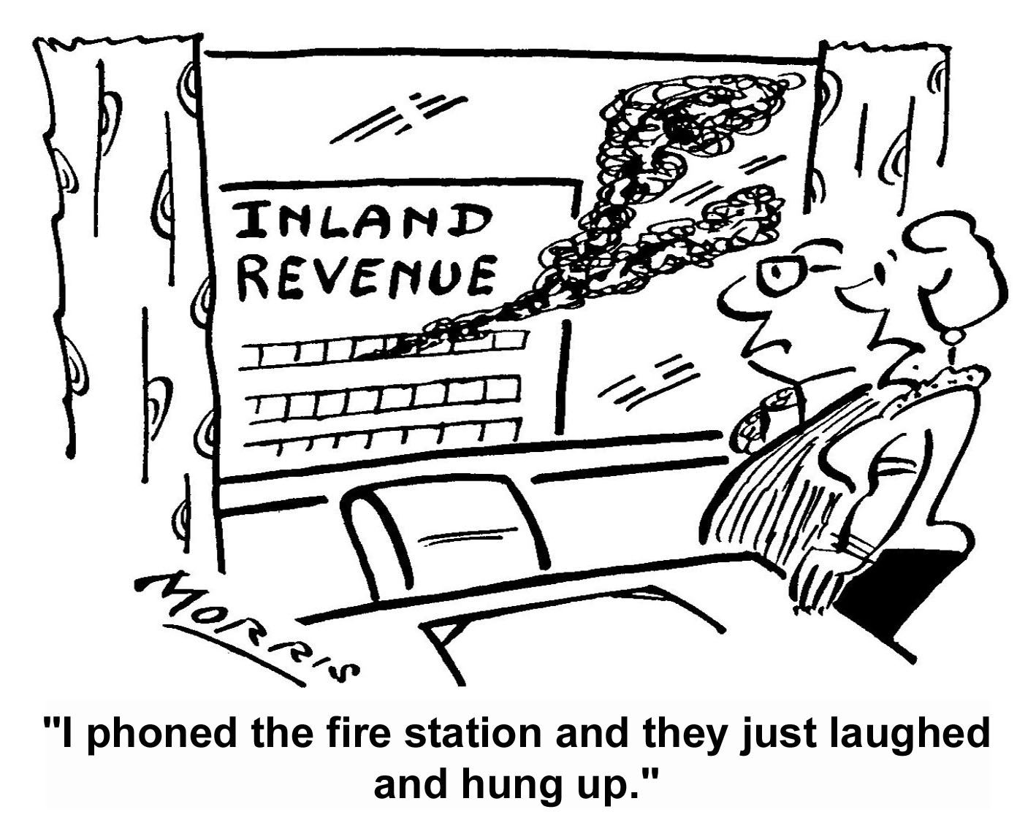

* **Lorem Ipsum** is simply dummy text of the printing ypesetting industry. nd scrambled it to make.

ISSUE 2 NEWSLETTER MAY/ JUNE 2014

**NALDRETT NEWS**

**BUSINESS TAX TIPS AND DODGES**

Jennifer writes articles, books and reports on tax related matters. The following is a reduced version of the points made in one such article published in Business Tax Insider.

**Why HMRC may choose your business for investigation**

* HMRC is under pressure to increase tax receipts and close the ‘tax gap’ namely the ‘*difference between the amount of tax that should, in theory, be collected by HMRC, against what is actually collected’.*
* The government has invested £900 million in tackling non-compliance in the tax system and by the end of this tax year expects this investment to generate up to £7bn per annum in additional tax revenues. This is to be achieved by more specifically targeted investigations.
* HMRC has the power to enquire into any return and request any information to establish whether that return is correct.

Worryingly - no reasons need be given and invariably will not be disclosed

* Reasons for investigation include:
  + Poor history of compliance (not least that the returns themselves have consistently been filed late).
  + Personal savings growing at a rate that cannot be explained by the level of drawings from the business.
  + Business expenses appear high for the type of trade, industry or location.
  + Accounts show a large and unexplained difference in the level of earnings, expenses or net profits in comparison year on year.
  + Information obtained from other sources (incl from a ‘wronged ex-spouse’ or ex-business partner)

**TIP** Well maintained records are a strong line of defense against an Inspector who alleges that the true business results are in fact better than the accounts show.

**Who will HMRC target?**

HMRC are concentrating their investigation efforts on ‘targeted campaigns’ run by ‘taskforces’. Teams formed from across HMRC, including criminal investigations, specialist investigations and local compliance departments use computer software in the tracing of likely tax evaders. Initially the aim is to investigate specific trades where there has already been evidence of tax evasion, expanding to other types of business. They have already ‘targeted’ electricians, plumbers, property owners, doctors and dentists.

**How much has been collected so far?**

* A total of £850m. The ‘Plumbers Tax Safe Campaign’ raised an extra £19 million in tax that otherwise would not have been raised but in comparison the ‘Property Sales Campaign’ netted only £28,666.

**TIP** You should watch out for...Channel 4 has commissioned a three-episode ‘fly-on-the-wall’ documentary series about HMRC, to be aired in 2015. The documentary will follow HMRC Inspectors and investigators as they go about their businesses of targeting what they term as "high-risk" sectors.

**YOU HAVE BEEN WARNED!**

Jennifer writes articles, books and reports on tax related matters. The following is a reduced version of the points made in one such article published in Business Tax Insider.

**George Osborne’s intends to recover tax liabilities direct from bank accounts**

In the Chancellors recent Budget the main centre of attention was, quite rightly, the reform of the pension rules. But hidden in the depths of the 120 pages that comprise the Budget document is a proposal that, arguably, should have been given more media attention - the proposal to automatically take tax owing direct from a taxpayers bank account.

The vast majority of taxpayers pay their tax bills in full and ontime - which means that some do not. There may be a number of reasons for not doing so, not least that the taxpayer is in dispute with HMRC over the amount charged. The Chancellor’s proposals headed ‘***The Provision for Direct Recovery of Debts’*** are not intended to be levied on such taxpayers rather the aim is to recover monies from those who have the means to pay but do not and those who do not pay purposely as delaying tactics.

**The Basics**

HMRC term the measures as ‘administrative’ but they are more than that – they will grant HMRC the power to collect payment of ‘significant debts’ (defined as being in excess of £1,000) directly from bank current or savings accounts (including ISA’s). It is intended that at least £5,000 will remain available to the taxpayer after the debt has been recovered (over and above normal calculated living expenses), thus supposedly ensuring that the procedure does not create unnecessary financial hardship for those affected.

HMRC already has the legal power to confiscate certain types of assets without recourse to the courts. However, there is no similar power to withdraw cash and as such these new provisions for compulsory withdrawal mean that HMRC will no longer have the expense of court proceedings.

**Procedure under the new Proposals**

HMRC have stressed that this is a ‘last resort’ procedure in that it will only be applied following attempts to make contact by both telephone and letter (stated as being ‘*a minimum of four plus letters and around nine in total including from teams of ‘specialist debtors’).* The ‘*team of specialist debtors’* is already in place in the form of HMRC’s Debt Management and Banking Team (DMB) which pursues tax debts that are in principle agreed, but have not been paid i.e. the liability is acknowledged to exist.

Under the intended procedure notification of its commencement will be issued to the taxpayer, who will then have 14 days in which to respond either to query the amount being taken or appeal on hardship grounds. Should HMRC not uphold the objection, the taxpayer will retain the right of judicial recourse. Once the procedure starts there will be another 14 days lapse with the monies being held in HMRC’s bank account, thus allowing further time for appeal but only on the grounds of undue hardship, or that the funds are not the taxpayers or that the debt is no longer due.

**Key point**

As the new procedure has been announced and, although subject to consultation, it will become law in some form or another very shortly. Even more reason that, should anyone have difficulty in paying their tax bill, they let us know asap. We will liaise with HMRC on your behalf and arrange installment payments. Please don’t leave it until you receive notification from the DMB - they are HMRC’s ‘heavy mob’ and will not take ‘no’ for an answer.

CONTENT

**COMPANY TAX TIPS AND DODGES**

Jennifer writes articles, books and reports on tax related matters. The following is a reduced version of the points made in a booklet written by Jennifer and published by Business Tax Insider.

In a private limited company it is usual for a director also to be a shareholder and as such there is a choice as to whether **payments are withdrawn as salary or dividend** or a combination of both. How much and by which method will depend on individual circumstances.

As from 6 April 2014 all businesses are entitled to claim an ‘Employment Allowance’ enabling the company to reclaim employers’ NIC payable up to a £2,000 limit. It will now usually be best advice for a company that has no employees other than directors to allocate a salary of £10,000 per annum (the amount of increased personal allowance for 2014/15) to each director. Paying this figure will mean that each director will pay an amount of £245 as employees NIC with the company paying employers NIC of £282.07 per director. **However,** the employer’s NIC payments will not be collected being less than the £2,000 limit.

The company gains in saving corporation tax as the gross amount of the directors’ salary is tax deductible from company profits - which more than makes up for the directors’ employee NIC payment.

**Example** : A sole director taking the additional £2,245 in salary will save £653.80 in corporation tax (£2,245 x 20%), producing an overall total saving of £408.80 (i.e. £653.80 less employees NIC of £245.00) plus this increases the amount available for distribution as dividends by the same amount. Dividends could then be taken up to £28,678.50 without paying any additional tax (where enough profit has been made and assuming there was no other income to be taxed). This new ‘Allowance’ is something that we will ensure all clients who are directors of their own companies take advantage.

**NEEDING HELP AND ADVICE?**

Please contact us if we can help you with these or any other tax or accounts matters.

In addition, if there’s anyone else whom you think would benefit from reading this newsletter, then please email to them or ask them to contact us to be added to the newsletter list with no obligation.

**New Clients Welcome**

If you are not already a client, are interested in becoming one and live in the Woking or Dorchester areas, we can meet and discuss how we can help – we will provide you with a competitive quote for our services. Should your base be elsewhere then we will be pleased to make contact via phone, email, text, Skype.....

All new client consultations are provided free of charge and without obligation.

**NALDRETT ACCOUNTANTS**

Woking Office: 01483 473494

Dorchester Office: 01300 341094

Mobile: 07831 502165

**Email: mail@naldrettaccountants.co.uk**

Website: [www.naldrettaccountants.co.uk](http://www.naldrettaccountants.co.uk)

This newsletter is written for the general interest of our clients and is not a substitute for professional advice. Please contact Naldrett Accountants for specific advice before taking any action

CONTENT